The Niche Duo

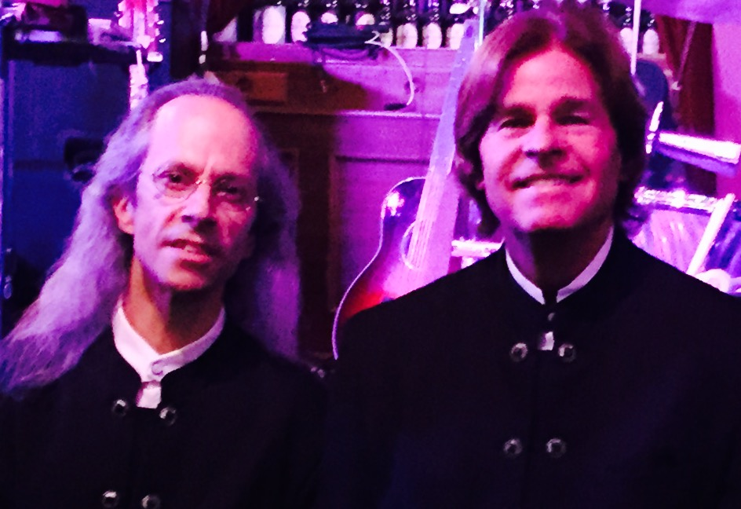

[Date]
[Time]
Enjoy the sounds and variety of a 12 string guitars, warm vocals, and harmonica in and eclectic mix of classic songs and contemporary music by such artists as Eric Clapton, The Beatles, Billy Joel, The Byrds, James Taylor, Paul Simon, John Lennon, Sting, Crowded House, Bob Dylan, and many others.

